# ENVIRONMENTAL MONITORING

#### INTRODUCTION

Environmental monitoring describes the processes and activities that need to take place to characterize and monitor the quality of the environment. Environmental monitoring is used in the preparation of environmental impact assessments, as well as in many circumstances in which human activities carry a risk of harmful effects on the natural environment. All monitoring strategies and programmed have reasons and justifications which are often designed to establish the current status of an environment and Prediction of the impact of future development and/or alteration in the operation and design of existing installations. Environmental Monitoring Network is operation phase of the project for monitoring of various environmental parameters like air, water, noise, soil etc. A well defined environmental monitoring programme would be employed with trained and qualified staff of Environmental Management Cell of the proposed expansion project to monitor the environmental attributes of the area with respect to EMP as well as the guidelines of the GPCB/CPCB. Environment monitoring schedule proposed to be adopted by the project.

Environmental monitoring refers to the tools and techniques designed to observe an environment, characterize its quality, and establish environmental parameters, for the purpose of accurately quantifying the impact an activity has on an environment.

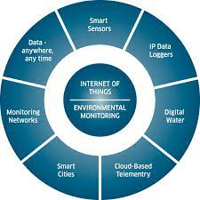

OBJECTIVES OF ENVIRONMENTAL MONITORING PLAN

To comply with the statutory requirements of monitoring for compliance with conditions of NOC and CC&A. ➢ To comply with the provision of Factory Act & MSIHC Rules. ➢ To verify the results of the impact assessment study in particular with regards to new development. ➢ Identification of any significant adverse transformation in environmental condition to plan additional mitigation measures; if & as required. ➢ To check or assess the efficiency of the controlling measures. ➢ To ensure that new parameters, other than those identified in the impact assessment study, do not become critical through the commissioning of new project. ➢ To establish a data base for future Impact Assessment Studies for new project.

****REQUIRMENT ANALYSIS****

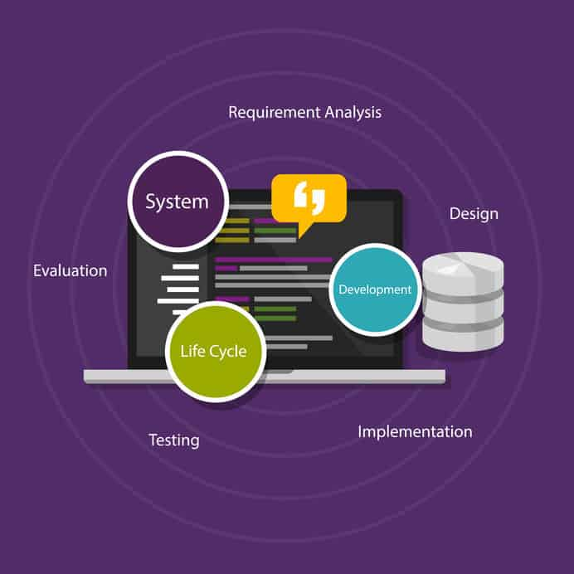

****Requirment analysis involves organizing requirements, modelling requirements and designs, validating information, identifying solutions that answer the business needs, and assessing the potential value gained by performing these tasks.****

Once the business analyst gathers all of the necessary information through [elicitation efforts](https://businessanalystmentor.com/elicitation-and-collaboration/" \t "https://businessanalystmentor.com/requirements-analysis/_blank), the business analysts can start their work on ****requirements analysis and design definition****. The analysis, structured, and stakeholder-verified requirements lay a foundation for design definition and ultimately developing a solution that will bring value to the organization.

The main distinction between requirements and designs is in the way they are used and who benefits from them. What is a requirement for one stakeholder can be a design for another. They both have their role in defining the change and can be overarching in their scope or precisely detailed depending on who they are intended for.

#### PROJECT ANALYSIS

For this study, the impact zone is confined to an angular radius of 5 km from the project boundary. For the purpose of certain environmental components, the radius has been extended up to 10 km as well. The EIA has been conducted to establish the baseline environmental situation in the study area, assessment of potential impacts on various environmental and social parameters, formulation of mitigation measures so as to keep negative impacts within acceptable limits and strengthen the positive impacts to make it more sustainable. The „Executive Summary‟ summarizes the findings of the EIA study to help the authority in decision making.It also provides project related information both to general public as well as to EIA authority. The summary of the report highlights the baseline environmental status of the study area, key environmental issues and their likely impacts. It also lists the mitigation measures proposed to be taken by the project proponent to ease the negative impacts.

#### ARCHITECTURE MONITORING

#### ****General-architecture-of-an-environmental-monitoring-system-based-on-crowdsensing****

One of the applications as a source of big data, there is a sensor network for--the environmental monitoring that is designed to detect the deterioration of the infrastructure, erosion control and so on. The specific targets are bridges, buildings, slopes and embankments due to the natural disasters or aging. Basic requirement of this monitoring system is to collect data over a long period of time from a large number of nodes that installed in a wide area. However, in order to apply a wireless sensor network (WSN), using wireless communication and energy harvesting, there are not many cases in the actual monitoring system design. Because of the system must satisfy various conditions; measurement location and time specified by the civil engineering;communication quality and topology obtained from the network technology; the electrical engineering to solve the balance of weather environment and power consumption that depends on the above-mentioned conditions. We propose the whole WSN design methodology especially for the electrical architecture that is affected by the network behavior and the environmental disturbance. It is characterized by determining recursively mutual trade-off of a wireless simulation and a power architecture simulation of the node devices. Furthermore, the system allows the redundancy of the design. In addition, we deployed the actual slope monitoring WSN that is designed by the proposed method to the snow-covered area.

#### CONCLUSION AND RECOMMENDATION

The environmental monitoring report consists of 4 the Semiannually environmental monitoring reporting based on identified parameters in EIA during construction phase. But till now the project construction activities is not started. So, no negative impact was found on the environmental due to this project. During construction activities all of the mitigation measures will be taken following ADB Environmental Safeguard Policy 2009, IFC/World Bank Thermal Power Plant Guideline 2008 and DoE, Bangladesh guideline and suggestive and recommended measures in the EIA. Finally it can be concluded that the project has no detrimental impact for short period on the environment in terms of ambient air, ambient noise and water during the period.